**Assignment # 2** **Deadline:** 2017-10-19

**Compare NSGA-II, SPEA2, MOEA/D Performance for Task Assignment Problem**

**Description:**

The aim of these experiments is to explore the jMetal5.2 and identify the most effective multi-objective algorithm, which gives an approximation set to the Pareto front of the problem with best convergence and uniform diversity.

**Problem: same problem we implemented in Assignment # 1**

Instead of one objective, now we will have two objectives:

1. Minimize cost
2. Minimize the infeasibility (violation of constraints)

Note: Run the experiments for problem D and you will not use problem-specific heuristics (as we implemented 2 heuristics in assignment# 1).

**Performance Comparison**

To compare and discuss the performance of NSGA-II SPEA2, and MOEA/D a set of computational experiments are performed. NSGA-II SPEA2, and MOEA/D are stochastic in nature and different replications can produce different results. In order to overcome this problem, we consider 10 independent replications for each algorithm and compare the results by considering mean and standard deviation.

In evolutionary algorithms, initial population size play an important role in the quality of the results. Different algorithms show different behavior on different population sizes. Considering constant number of ﬁtness evaluations, population size can play an important role in evolution. There is some trade-off as far as size of the population is concerned. For example if we assume small population size, then sometimes less number of evaluations may be required for convergence of the population to the Pareto-optimal solutions. But sometimes smaller population can be cause of pre-mature termination (algorithm can be trapped by local minima/maxima). To make the discussion fair, for each problem size, we conduct 10 replications of each algorithm on ﬁve different initial population sizes (20, 40, 80, 160 and 320) and each algorithm terminates after 100, 000 function evaluations. For each replication, we calculate the **Hypervolume, Spread and GD, and IGD** of the obtained Pareto front.

**Calculate mean and standard deviation of Hypervolume, Spread and GD, and IGD of 10 replications for each population size.**

**Example Plot:** Draw plots for Hypervolume, Spread and Coverage as shown in Figure 3.3. You also have to include curve for MOEA/D.

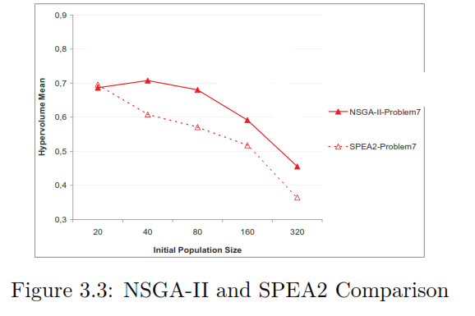

**Reference Pareto front:**. For each problem, we integrate all obtained nondominated set of solutions for all 10 replications on 20, 40, 80, 160 and 320 initial population sizes.

Assignment should be done in jMetal5.3, the algorithms are already implemented, you have to explore the framework and perform the experiments. You need to submit plots with results in tables and the source files.

http://jmetal.github.io/jMetal/

https://github.com/jMetal/jMetalDocumentation